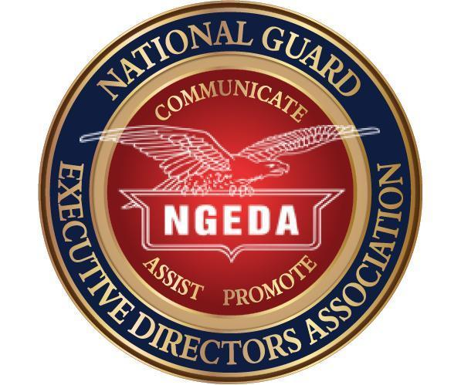

DATE: October 31, 2024

MEMO TO: Executive Directors, Association Presidents, Insurance Administrators, Industry Partners, Life Members, Gamble Award

FROM: Maria Kelly, Secretary

SUBJECT: Official Call, 2025 Annual Meeting, Milwaukee, Wisconsin

The Annual Meeting of the National Guard Executive Directors Association will be held January 27-30, 2025, at the Hyatt Regency Milwaukee, 333 West Kilbourn Avenue, Milwaukee, WI, 53203. The attire for the meeting will be business casual.

**Monday, 27 January 2025**

Travel Day

Registration

Welcome Reception - hosted by NGAUS and WINGA

**Tuesday, 28 January - Thursday, 30 January 2025**

NGEDA Annual Meeting for all participants

Includes business meetings, hotel tours and selection, Corporate Advisory Panel (CAP) meetings, Tradeshow Hall site visit, Payroll Deduction Coordinating Board (PDCB) meeting, breakout sessions, elected officer sessions, social events, sponsored events, awards dinner and more!

# *Registration*

You may [register](https://ngsecure.pinnaclecart.com/index.php?p=catalog&parent=42&pg=1) using the **online registration form** found at [www.ngeda.org](http://www.ngeda.org). Please ensure your registration is completed online or returned to [mariakellyllc@gmail.com](mailto:mariakellyllc@gmail.com) by 31 December 2024. Please note that your association or company must first be a member to register for the conference. Association annual membership is $300.00 and then an additional $150.00 registration fee per person attending. Corporate Membership is $200 per company and then an additional $150.00 per person attending the conference. State associations are encouraged to bring elected officers to participate in collaborative sessions. Additionally, enlisted association Executive Directors can attend as a guest if the state association chooses to list them as one of their named members.

***Hotel***

The group rate at the hotel is $140.00 plus taxes. All hotel reservations can be made using the following link: <https://www.hyatt.com/en-US/group-booking/MKERM/G-NGDA>

You may also make your reservations by calling one of the following numbers and using the group code provided: 888-421-1442 or 402-592-6464 – G-NGDA or 2025 NGEDA Annual Meeting.

Please reserve your room early**. The *hotel cut-off date* to guarantee the group rate is 29 December 2024.** Rooms are only available until the NGEDA room block is filled. The cutoff date of December 29th does not guarantee that rooms will still be available on that date.

***Transportation: For those arriving at the Milwaukee Mitchell International Airport***

Taxi service is available via the taxi pickup station located outside of Baggage Claim 3. Cross the Baggage Claim roadway, and follow the signs to the taxi lane behind the rental car area. Uber & Lyft follow the signs near Carousel 2.

Shuttle operators provide door-to-door airport service to hotels and all other locations in southeastern Wisconsin and northern Illinois, including Chicago.

[GO Riteway Transportation Group](http://www.goriteway.com/)Milwaukee Area  
1-800-236-5450

***Agenda***

A **draft** agenda for this year’s conference is posted at [www.ngeda.org](http://www.ngeda.org). This year will feature many classes designed to meet the needs of our executive directors, association officers, and insurance administrators. As the agenda is finalized updates will be posted at www.ngeda.org.

# *NGAUS 2025 Hotel Visit*

The NGAUS Conference hotel “visits” are scheduled for Tuesday, 28 January. Due to the large number of hotels contracted for the conference, hotel sales personnel will meet with state association representatives at the Hyatt. States should be prepared to pay room deposits ($100 per room and $200 for suites) by check or credit card at the time of their hotel selection meeting with the WINGA representatives on Wednesday, 29 January 2025. Please note that only two persons from a state are allowed on the hotel site visit. All hotel assignments will be confirmed prior to the adjournment of the NGEDA meeting on Friday. The hotel lottery for the Annual Conference in Indianapolis in 2026 will be conducted on Thursday, 30 January 2025.

***Sponsorship***

There are many opportunities for our industry representatives to sponsor some of the breaks and entertainment functions. Your generous support in the past has provided the opportunity to experience a first-class meeting with a very low registration fee. We ask our industry friends to please support us with their sponsorship of an event as noted on the attached sponsorship form.

**For Industry Partners:**

NGAUS will also be conducting a tour of the Convention Center for our Industry partners on Tuesday, January 28, 2025, at 1 pm while the States tour the hotels*.* The convention center is adjacent to the Hyatt Regency, so you will not have to travel outdoors. The tour will include a brief visit to the trade show floor space, loading dock area, registration area.

If you have any questions or comments concerning the NGEDA meeting please do not hesitate to call Maria Kelly at 614-989-6894.

We look forward to seeing you in Milwaukee!

Maria Kelly

NGEDA Secretary