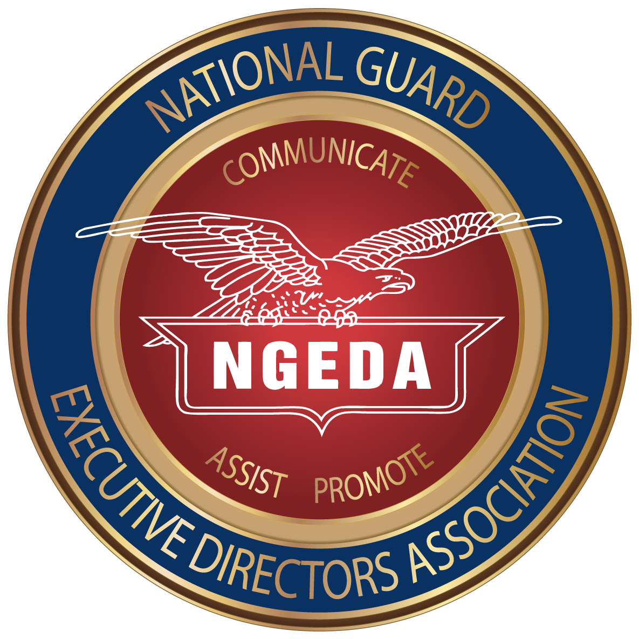**Annual Conference Sponsorship Opportunities\***

The NGEDA Annual Conference is scheduled to be conducted 27-30 January 2025.

Your sponsorship of one of the breaks will give your company the opportunity to gain invaluable exposure during this three day meeting which includes state association leadership from the 50 states, 3 territories and the District of Columbia. Sponsorship is reserved for NGEDA Corporate Members.

Full break sponsors: select break (am or pm); will get to make a five minute presentation with slides; will receive one complimentary conference registration.

Co-sponsors will be introduced prior to the break and may submit one slide.

Quarter sponsors will be recognized prior to the break.

**Please send your check NLT 5 January 2025 to:**

**NGEDA, Attn: Maria Kelly, One Massachusetts Avenue NW, Washington, D.C. 20001**

## 

**Coffee Break Snack Break**

**Function Full Sponsor Co-Sponsor Quarter Sponsor**

**Tuesday (1/28)**

Break a.m. $2,000 $1000 $500 $ _________

**Full Sponsor Co-Sponsor Quarter Sponsor**

**Wednesday (1/29)**

Break a.m. $2,000 $1000 $500 $ _________

Break p.m. $2,000 $1000 $500 $_________

**Co-Sponsor Full Sponsor Co-Sponsor Full Sponsor**

**Thursday (1/30)**

Break a.m. $2,000 $1000 $500 $ _________

**Total amount enclosed** **$ _________**

Company Name: ____________________________________________________

Contact Person(s): __________________________________________________

Mailing Address: ______________________ City_____________ State ______ Zip _______

Phone Number: ________________________ E-Mail: ________________________

*\*All sponsors must also be NGEDA Corporate Members*